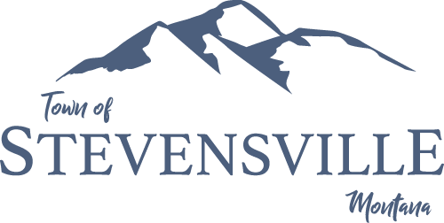

parks & recreation director

Supplemental Essay Questions

In order to get a better sense of your writing skills and additional insights into your experience, please answer the following questions. Limit your responses to no more than a single page per question and submit your answers as part of your application.

- What have you learned about the Town of Stevensville that makes you interested in this position, and why is now a good time in your career to consider applying for this position?

- What does delivering a public service mean to you?

- The Park Board is currently working on a Master Parks Plan. This position will be key in developing the plan. Please describe your experience in this area.

